Assess Your Hourly Charge Rate
Many accounting technicians who work as solo practitioners or in micro teams base their professional charges either exclusively or primarily on hourly rates.
One of the issues we face now, more than say five years ago, is that we must spend a lot more time to maintain professional currency and education. As payroll and GST laws continue to increase in complexity and as software continues to evolve at top speed, we must devote more time to staying educated and informed about software and legislation. Add in unusual events like having to learn a great deal about government assistance for COVID-19 in a short time, and you have to dedicate even more time to professional development.
This means less time available for billable working hours. So, if this is your primary method of billing clients, how will you adapt to the changing demands of the industry so that you continue to receive an appropriate amount of remuneration for your level of qualification and expertise in less billable hours?
Added to this factor is that software and automation have sped up data processing time, so we can get more done in less time. If you’re billing solely on time, you’re losing out because the customer gets the same result but you’re earning less if you’re only charging for time.
Another factor is that naturally we improve over time at whatever tasks we repeatedly perform. Therefore, over time, the customer receives greater value from your knowledge and experience.
Increased CPE Requirements Means Less Billable Hours
Currently, all AAT members must commit to 15 hours per year of continuing professional development. The Tax Practitioners Board requires 90 hours over three years, with a minimum or 20 hours per year.
Add to this your own administration time, business development time, further education, managing staff and your wellbeing… all these factors impact the amount you can sustainably work.
It’s imperative to plan for professional development and other unbillable time every week as part of your ordinary working hours. If you rely solely on hourly billing, your earning capacity will be reduced unless you plan to work more hours to accommodate the required CPE or change how you charge for your services. This is fine for a short-term situation, but not workable over the long term.
Hourly billing is appropriate in many situations; there is nothing wrong with this way of billing clients. However, it is important to understand the limitations on your earning capacity if this is the only way you bill clients. If you only bill by the hour, your earnings will always be tied to the number of hours you work. Because there are a limited number of hours you can work in a given week, month or year, your income will necessarily be limited unless you continually raise your prices to accommodate reduced billable hours and increased value to clients or look at other ways of charging clients.
How Much Are You Really Earning?
AAT has a charge rate template you can use to work out how much you should be charging for hourly services. The template includes calculations for the actual costs of running your practice, earnings, superannuation, administration time and leave.
If you have never done the exercise, or if it is more than a couple of years since you have worked through the template, do this now to get real about how much you are earning and how much you can potentially earn in the hours available to you.
This is a great exercise to do whenever you consider putting up your rates or rearranging how you run your practice and invoice your clients. There is no problem with providing services at hourly rates, so long as you are realistic about your costs and planning.

The spreadsheet calculates the minimum average hourly rate you need to charge based on the information you input for overheads, billable and unbillable hours per year, leave, super, tax, personal expenses.
The example below is for a BAS agent working full-time as a sole practitioner. Customise the spreadsheet according to your situation.
Business Overheads
First, add in the expenses incurred in running your practice to calculate the annual overhead cost.
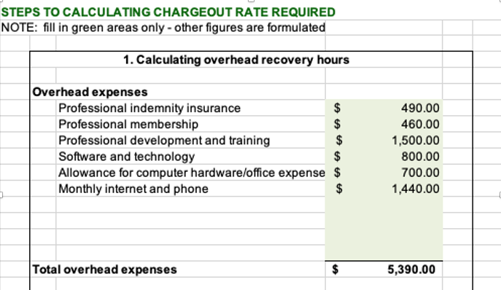

Productive Time
Second, calculate your productive time per year and week according to the number of days worked per week on average, leave taken and administration time. This varies a great deal from practitioner to practitioner, so be realistic about your situation.
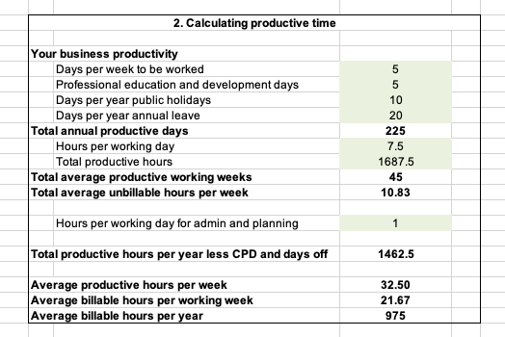
From this example, you can see that someone who works an ordinary full-time week, takes four weeks of leave, doesn't work public holidays and completes the equivalent of 5 days of professional development per year averages 21.67 billable hours per week. This person needs to earn enough to 'pay' for 37.5 hours in less than 22 hours.

Required Earnings
Third, calculate other costs such as superannuation, tax, drawings needed for personal living expenses, loans, and any amount required to invest back into your business.

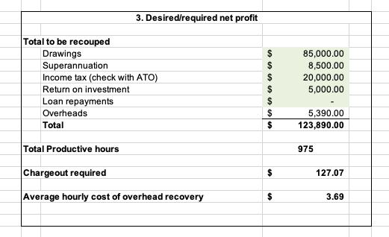
The spreadsheet then gives you the minimum average hourly rate required to meet your criteria.
For this person who needs to earn $123,890 to cover all business and personal expenses after factoring in unbillable hours, the rate becomes $127.07 per worked hour on average.
You can see that for someone who needs to earn more or has a loan or wants to make a certain percentage of profit, the billable rate would increase again.
Next, run your profit and loss statement to compare what you are actually making to the scenario details you have entered on the spreadsheet. Does it tally up? Are you making what you want to? Are your costs and hours realistic? Adjust the spreadsheet inputs to reflect your actual situation – not forgetting to include the amount of time needed for professional development!
What Next?
This spreadsheet exercise is a guide – it is not absolute. For example, if you need to earn only say $50,000 per year for personal expenses, this will reduce your minimum average hourly rate required. However, the charge rate decision must be considered with many other factors – including qualifications, experience, specialisations, the nature of services provided, the nature of the engagement, competition, and market rates.
This exercise will help you assess whether it is realistic to earn what you need based solely on hourly billing. You may decide that you are being remunerated appropriately, have enough to live on, and are content with the arrangement. Or you may be interested in looking at other models of billing – check the AAT Fee Structures article as a starting resource.
AAT – Calculating Charge-Out
AAT – Fee Structures
Certified Accounting Technician Program

