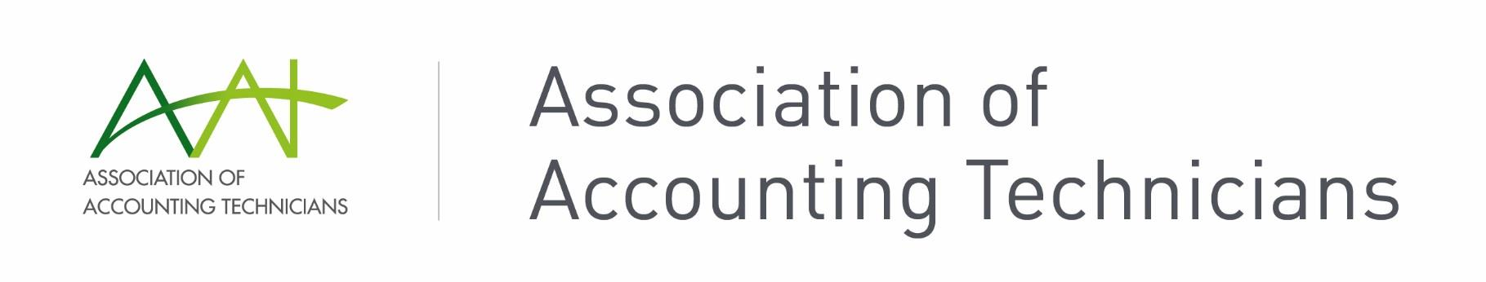
Single Touch Payroll FAQs
Q. Who needs to report?
A. All employers must report STP directly from compliant payroll software or by using standard business reporting software.
Q. When does each pay event need to be reported by?
A. The ATO stipulates pay events must be report on the day of, or before the date of payment.
Q. What are the penalties for late lodgements?
A. Late lodgment penalties are the same as failure to lodge activity statement penalties, that is, one penalty unit per 28 days, up to a maximum of five units. The penalty unit value from 1 July 2020 is $222.
Q. Who can lodge STP pay events?
A. Any authorised person in the business can lodge STP pay events once the software is set up and connected to the ATO, provided they have payroll admin access. BAS agents are able to lodge on behalf of the business, however bookkeepers may not lodge STP unless they are employees and authorised by the owner.
Q. Do I need an authority form?
A. Authority forms are required for BAS agents who will lodge STP pay events on behalf of clients. An authority is required for each lodgment.
BAS agents can use an annual authorisation for lodgments if they meet the criteria.
Check the AAT resource STP Client Engagement Authority to Lodge Annual.
Q. What happens if an employee doesn’t have a MyGov account?
A. STP data is automatically uploaded to the employee myGov account. The employee can request a payment summary from the employer if they do not wish to access the information via their myGov account.
Q. Does STP change payment schedules for PAYG or superannuation?
A. No. STP reports tax and super information to the ATO, but it does not change payment schedules for liabilities.
Q. When is the final declaration for STP due each year?
A. STP final declaration is due by 14 July each year.
Q. Can payment summaries still be printed from software?
A. Yes, each software has a different process for accessing the income statement, or payment summaries, but generally you can choose to run individual payment summary reports separate to STP reporting. Some employees may still request a document, even though they have the information available in their myGov account.
Q. How do we account for directors’ adjustments/end of period additions?
A. Anything needing to be included in the year’s payroll should be entered via a pay run, whether it’s a standard or adjusting pay run entry. These end of year payments should be included in STP reporting.
Q. How do we report closely held payees’ payments?
A. Closely held payees such as directors must have actual payments reported on or before the date of payment, the same as arm’s length employees. If amounts are estimated based on an annual payment, the estimates must be reported quarterly with the relevant PAYGW and superannuation.
Q. What is Single Touch Payroll Phase 2?
A. STP Phase 2 is an expanded reporting system that submits more information to the ATO. There are more categories of reporting to allow greater detail for types of wage payments, taxes, allowances and termination reasons. The detailed information is reported to other government agencies such as Services Australia with more planned in the future.
Q. What has changed with Single Touch Payroll Phase 2?
A. Gross payments are reported in greater detail, defining amounts for gross, paid leave, allowances, overtime, bonuses, commissions, director fees, lump sum payments and salary sacrifice.
Employment conditions, income types, tax types, country codes and child support payments are included in STP 2.
Phase 2 will also allow tax file number declarations to be submitted from the payroll software.
There are no changes to due dates, payments, tax and super obligations, or end of year finalisation requirements.
Q. When is Single Touch Payroll Phase 2 starting?
A. STP Phase 2 was due to start on 1 January 2022. Some software providers are already reporting STP Phase 2, but others have a deferral in place with the ATO allowing them more time to transition to the more involved reporting.
If your payroll software is ready for STP 2 you should start using it. If your payroll software is not yet ready, they will let you know when the mandatory start date applies. Currently this ranges from 31 December 2022 to 31 March 2023 depending on the provider.

