MYGOV ONBOARDING INFORMATION FOR EMPLOYEES
Welcome to your new role with {INSERT EMPLOYER HERE}. We need to gather some information about your circumstances and have it verified by the ATO.
There have recently been changes made to how an employee can share this information with their new employer. Below are instructions for how you can provide us with the information that we need to set you up as an employee and pay you and your superannuation.

WHAT DO YOU NEED TO DO?
You can access and complete the forms via your personal myGov account. If you haven’t already set up your myGov account and connected to ATO Online services, you can find out how to do this here.
From your myGov account you need to follow the instructions to link to the ATO first.
Open the ATO online service. Once you have re-directed to that page, select the drop down option on the Employment tab and select the New employment option:

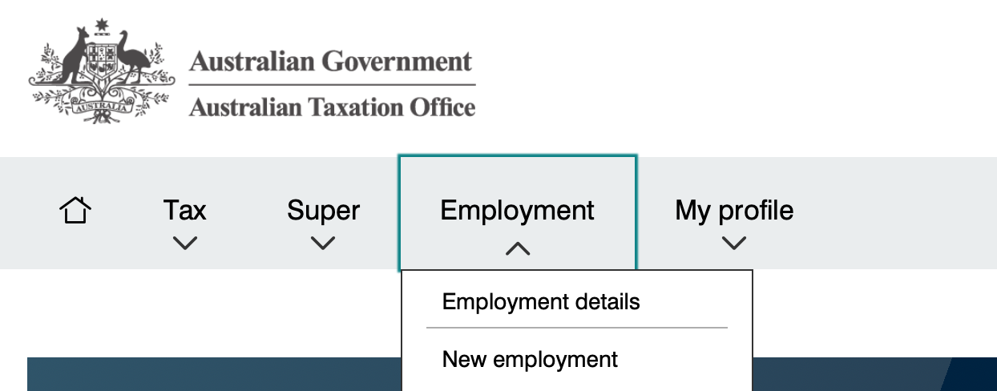

You will then need to input the information to the tax and super information forms on this screen related to {INSERT NAME OF EMPLOYER HERE} so that the ATO is aware you are now working for us, and we can receive the information required to pay you and your superannuation correctly.

THE INFORMATION YOU NEED ABOUT US
OUR ABN OR WPN | {INSERT EMPLOYER ABN}
OUR EMPLOYER BRANCH ID | {INSERT EMPLOYER BRANCH ID}
YOUR EMPLOYMENT TYPE | {SELECT FULL-TIME/PART-TIME/CASUAL}
OUR DEFAULT SUPER FUND | {INSERT FUND NAME}
DEFAULT SUPER FUND ABN | {INSERT FUND ABN}
DEFAULT SUPER FUND USI | {INSERT FUND USI}

INFORMATION YOU WILL NEED TO COMPLETE THE PROCESS
In order to coplete your tax and superannuation details, you will need the following:
- Your tax file number (TFN). If you do not yet have a TFN, apply for one here.
- Your superannuation fund details including name, ABN and USI. Contact your preferred superannuation fund for these details if you are not sure.

NEXT STEPS
- Print or save to PDF the forms from the ATO new employment process.
- Provide the forms to us witin 14 days of the start of your employment: [insert due date].
- If you are unable to setup or access your myGov account, download and complete the forms: superannuation choice form and tax file number declaration.

